YE OLDE CAR CLUB APPLICATION FORM

Last Name: ___________________ First: ________________ Spouse: ______________

Address: _______________________City: _________________State: ____ Zip: ______

Home Phone: __________ Cell Phone: __________ E-Mail: ______________________

Anniversary: __________Your Birthday: _________Spouse Birthday: _____________

Classic Cars Owned: _______________________________________________________

_________________________________________________________________________

Please Submit with your check for $20.00 for annual dues to
Ye Olde Car Club, Box 2023, Richland, WA 99352

YE OLDE CAR CLUB

Ye Olde Car Club of the Tri-Cities was officially chartered in 1963 to preserve and maintain motor vehicles of historical value and to serve as an accurate and technical source of information concerning historical automobiles for the benefit of its members as well as the general public.
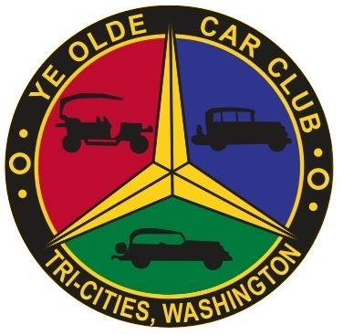
Ye Olde Car Club is headquartered in Kennewick, Washington and has members primarily from Southeast Washington, Western Washington, Idaho and Alaska -- over a hundred individuals and families with nearly 400 antique and classic automobiles.
Aside from regular weekly and monthly meetings, club members participate in frequent community and social events, driving tours both short and long, and a variety of activities each month. Annual dues are only $20, with the only membership requirement being an appreciation for historical automobiles.
As an old car club, we are also there to guide you when you decide to buy an old car, help you to restore it, share stories about your car, and provide whatever it takes to see that owning an old car is an enjoyable experience for you! Our club has among its members a wealth of knowledge about the auto industry that we would love to share with you. Our members usually can be found at the weekly Wednesday meeting at Sterling’s Restaurant, 2500 Queensgate, in Richland at 7am or our monthly meeting very fourth Thursday at Roundtable Pizza, 1769 Leslie Rd, Richland, at 5:00 pm. Come and say "Hi". You'll be surprised at how much fun can be had for only $20 a year!

