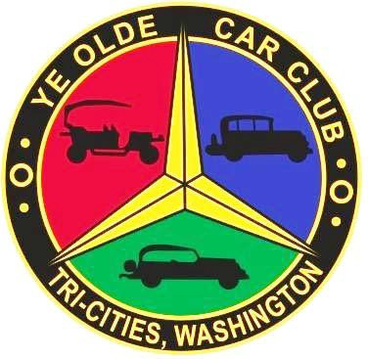
TRI-CITIES 46th ANNUAL SWAP MEET & ANTIQUE CAR DISPLAY
2024
BROUGHT TO YOU BY YE OLDE CAR CLUB OF TRI-CITIES
SATURDAY, MAY 4th, 2024
8 AM to 5 PM BENTON COUNTY FAIR GROUNDS, KENNEWICK, WA
1500 S. Oak St., Kennewick, WA - USE 10th Ave. Entrance
FOR MORE INFORMATION CALL BILL WHITE 509-554-3665
BUY/SELL/TRADE/CARS/PARTS/COLLECTIBLES

Inside Spaces (A thru F)  10’ X 10’ | Outside Pavement (P) and (O)  10’ X 20’ | Outside Grass (G)  15’ X 30’
$30 pre-pay | $30 pre-pay | $35 pre-pay
$35 after April 22nd | $35 after April 22nd | $40 after April 22nd
(No cars for sale in bldg.)
RV Spots $20 per night

Vendor setup Friday noon to 7 pm & Saturday at 6 am

SEE BACKSIDE OF THIS PAGE FOR SPACE RESERVATIONS AND HOLD HARMLESS AGREEMENT

No reservation granted w/o payment | MAKE CHECKS PAYABLE TO:
 | YOCC SWAP MEET
Pre-registration and payment must be received by Friday, April 22nd, 2024  For confirmation and receipt, send a stamped self-addressed envelope with payment | c/o Bill White  2321 S. Highlands Blvd.  W. Richland, WA 99353  509-554-3665  williambllwh@yahoo.com

HOLD HARMLESS AGREEMENT

All registered participants of Ye Olde Car Club Swap Meet MUST; agree to, sign, and date this agreement. Requests for space(s) rental will not be granted without a signed HOLD HARMLESS AGREEMENT in the possession of an officer of Ye Olde Car Club.

OPERATION: Event management reserves the right to restrict participants to acceptable behavior during Ye Olde Car Club Swap Meet. Loud sound systems, or for any other reasons a participant’s appearance or conduct is deemed objectionable by event management, will subject participant to eviction from the premises. This reservation includes persons, things, conduct, printed matter, or any act or item of poor character which the management considers objectionable to the event's well-being. In the case of any eviction or restriction, Ye Olde Car Club will NOT refund entry fees.

LIABILITY: In consideration of the acceptance of the right to participate, participants, and spectators, by execution of this entry form, release and discharge Ye Olde Car Club, the State of Washington, Benton County, the City of Kennewick, the Kennewick Area Chamber of Commerce, directors, employees, agents representatives, volunteers, and servants, and anyone else connected with the management or presentation of Ye Olde Car Club Swap Meet of and from any and all known damages, injuries, losses, judgments, and/or claims from any cause whatsoever that may be suffered by participant's person or property. Further, each participant expressly agrees, to the extent permitted by law, to indemnity and hold harmless all of the foregoing entities, firms, persons, and bodies, of and from any and all liability occasioned by or resulting from the conduct of any participants under the direction or control of participant. Participants must be 18 years of age. I have read this agreement and agree to all conditions to enter in Ye Olde Car Club Swap Meet and to the rules governing the event as set forth on this form and to observe all rules and decisions of event management. PLEASE SIGN THIS AGREEMENT. UNSIGNED FORMS WILL NOT BE ACCEPTED.

NAME
SIGNATURE DATE

YE OLDE CAR CLUB
2024 SPACE RESERVATION INFORMATION
Requested Space(s) # _____________________________

 | QUANTITY AMOUNT
Name______________________________
Email______________________________ | ______Inside (A - F) 10’x10’ $30/$35_____
Address____________________________ | ______Outside (O/P) 10’x20’ $30/$35_____
City, State, Zip_______________________ | ______Outside (G) 15’x30’ $35/$40_____
Cell or Phone________________________ | ______RV Nights $20_________
 | Total $___________

