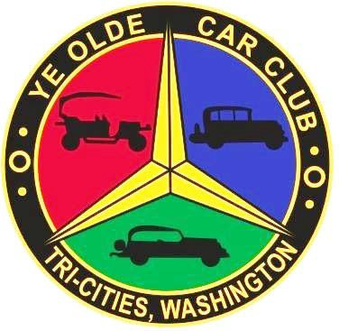
TRI-CITIES 44th ANNUAL SWAP MEET & ANTIQUE CAR DISPLAY
BROUGHT TO YOU BY YE OLDE CAR CLUB OF TRI-CITIES

SATURDAY, MAY 2nd, 2020
8 AM to 5 PM - BENTON COUNTY FAIR GROUNDS, KENNEWICK, WA
1500 S. Oak St., Kennewick, WA - USE 10th Ave. Entrance

FOR MORE INFORMATION CALL Bill White (509) 554-3665

BUY - SELL - TRADE CARS - PARTS – COLLECTIBLES
Inside Spaces 10’ X 10’ |  | Outside Spaces 10’ X 25’ |  | Outside Spaces 10’X 30’
(No cars for sale in bldg. |  | $20 pre-pay |  | $25 pre-pay
$20 pre-pay |  | $25 after April 27th |  | $30 after April 27th
$25 after April 27th

Vendor setup Friday noon to 7 pm & Saturday at 6 am

YE OLDE CAR CLUB
2020 SPACE RESERVATION INFORMATION
Space #
Name |  |  |  |  | QUANTITY |  | AMOUNT
Email |  |  |  |  | Inside 10 X 10 |  | $20/$25
Address |  |  |  |  | Outside (Grass)  10 X 25 |  | $20/$25
City, State, Zip |  |  |  |  | Outside (Grass)  10 X 30 |  | $25/$30
 |  |  |  |  | Outside (Pavement)  10X20 |  | $20/$25
Cell or Phone |  |  |  |  | RV per night |  | $20
Type of merchandise |  |  |  |  | Total

No reservation granted w/o payment |  | Make Checks Payable to:
Pre-registration and payment must be received by Monday, April 27, 2020  For confirmation and receipt, send a stamped self-addressed envelope. |  | YOCC SWAP MEET  c/o Bill White  2321 S. Highlands Blvd  W. Richland, WA 99353  509-554-3665  williambllwh@yahoo.com

